9/5/2025



**Analysis Report of Fellowship Week 1**

[Document subtitle]

## Key Metrics Details & Introduction

The DS Fellowship 1 Feedback Dashboard compiles participant feedback, including demographics, ratings, preferences, and key insights. The data is current as of September 05, 2025, and is visualized in Monday.com.

The purpose of this dashboard is to evaluate the program's effectiveness, highlight its strengths, identify areas for improvement, and inform future iterations through interactive visualizations. Key metrics include:

* **Demographics:** The fellowship is predominantly male (84.6%), with females at 15.4%. The age distribution shows the highest concentration in the early to mid-20s.
* **Satisfaction:** Participant satisfaction is high, with excellent ratings for overall experience and facilitator clarity. A crucial finding is that 100% of participants reported benefiting from daily tasks.
* **Engagement:** Preferences for task frequency are mixed, with 38.5% strongly agreeing and 30.8% agreeing to the current format, while 15.4% disagree. Confidence levels vary by role, with seniors and professionals exhibiting higher "very confident" ratings.

This report will derive nuanced insights by combining data from different columns, such as gender with encouragement sources or role with improvement suggestions.

## Dashboard Overview

The dashboard features a variety of charts and widgets that display participant feedback.

### Demographics Charts

* **Age Distribution:** A horizontal bar chart shows the count of participants across different age groups, segmented by gender. The highest participation is seen in the early to mid-20s. Insert the Age Distribution chart screenshot here.
* **Gender Distribution:** This pie chart visually represents the gender breakdown of participants, with male participants at 84.6% and female participants at 15.4%. Insert the Gender Distribution pie chart screenshot here.

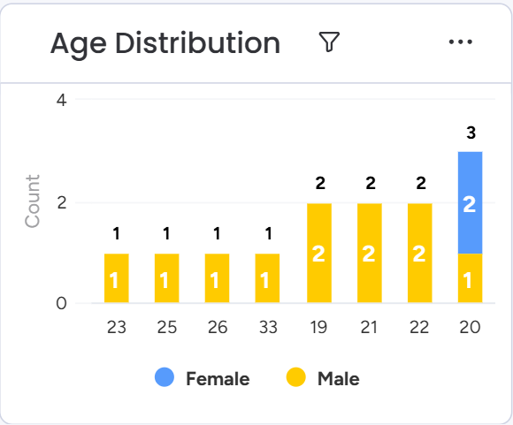

### Ratings & Preferences Charts

* **Overall Experience vs. Facilitator Clarity:** A stacked column chart that shows high ratings for both overall experience and facilitator clarity, primarily in the "good" and "excellent" categories. Insert the Overall Experience vs Facilitator Clarity chart screenshot here.

* **Weekly vs. Daily Preference:** This pie chart breaks down participant opinions on task frequency. While a strong majority agrees with the weekly tasks, a notable percentage is neutral or disagrees. Insert the Weekly vs Daily Preference pie chart screenshot here.

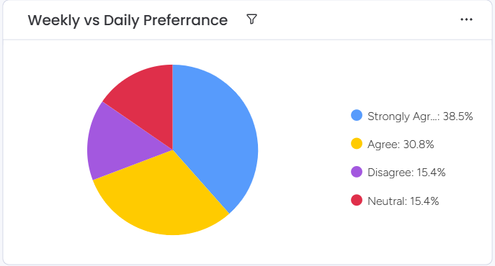

* **Benefit From Daily Tasks:** A doughnut chart that shows a unanimous positive response, with 100% of participants benefiting from daily tasks. Insert the Benefit From Daily Tasks chart screenshot here.

### Insights & Combined Data Charts

* **Understanding Concepts vs. Future Confidence:** This stacked column chart combines participant roles with their confidence levels ("somewhat confident" vs. "very confident") to show how confidence varies across different professional stages. Insert the Understanding Concepts vs Future Confidence chart screenshot here.

* **Messages For Peers vs. Gender:** A bar chart that categorizes the types of messages participants share with their peers, segmented by gender. This chart highlights the different topics males and females emphasize. Insert the Messages For Peers vs Gender chart screenshot here.

* **Encouragement vs. Gender:** A line chart that plots different sources of encouragement (Resources, Learning, Motivation) against gender, revealing trends in what motivates male and female participants. Insert the Encouragement vs Gender chart screenshot here.

* **Improvements vs. Role:** A column chart that displays suggestions for program improvements, segmented by the participant's role. This shows which roles prioritize certain changes, such as functionality or community support. Insert the Improvements vs Role chart screenshot here.

* **Fellowship Benefits vs. Country:** This column chart compares the benefits received (Mentoring, Networking, etc.) across different countries like Nigeria and Pakistan. Insert the Fellowship Benefits vs Country chart screenshot here.

* **Fellowship Takeaways vs. Role:** An area chart that visualizes the key takeaways for participants, such as "Growth" or "Confidence," categorized by their role in the fellowship. Insert the Fellowship Takeaways vs Role chart screenshot here.

All charts are well-labeled with titles, axes, and legends for clear interpretation.

## Insights & Analysis

The analysis of combined data from the dashboard reveals several key trends and patterns:

* **Demographic Imbalance:** The fellowship has a significant gender disparity, with males making up 84.6% of the participants. This imbalance is an important area for future consideration.
* **High Program Effectiveness:** The fellowship is highly effective in its core functions, as demonstrated by the strong ratings for overall experience and the unanimous agreement that daily tasks are beneficial.
* **Varied Needs by Role & Gender:** The data indicates that different participant segments have unique needs. Senior and professional participants are generally more confident, while male and female participants have different priorities for encouragement and peer messages.
* **Localized Benefits:** The program's benefits are perceived differently depending on the participant's country. For example, Nigeria shows higher engagement in benefits like Collaboration and Program Structure compared to Pakistan.
* **Key Areas for Improvement:** The top suggestions for improvement relate to "Functionality" and "Community," indicating that while the core content is strong, there's an opportunity to enhance the user experience and social aspects of the program.

Overall, the program is successful in engaging participants and fostering growth, but there is room for improvement in diversity, personalization, and community-building.

## Recommendations

Based on the insights and analysis, here are actionable recommendations to enhance the DS Fellowship program:

* **Boost Diversity:** Implement targeted recruitment strategies to attract more female and underrepresented participants, with a goal of achieving a more balanced gender ratio in future cohorts.
* **Optimize Task Structure:** Given the mixed preferences for task frequency, offer flexible options. This could involve providing both weekly and daily task tracks, allowing participants to choose what best fits their schedule.
* **Customize by Role:** Tailor content to meet the specific needs of different roles. For example, offer specialized sessions or workshops to boost confidence for junior participants and address functionality suggestions from professionals.
* **Localize Benefits:** Strengthen networking and mentoring opportunities in specific regions, such as Pakistan and the Philippines, to provide more localized support and improve the perceived value of these benefits.
* **Sustain Engagement:** Continuously monitor feedback on encouragement and motivation to ensure high participant engagement throughout the fellowship, which is crucial for maintaining high satisfaction ratings.